Supplementary Material

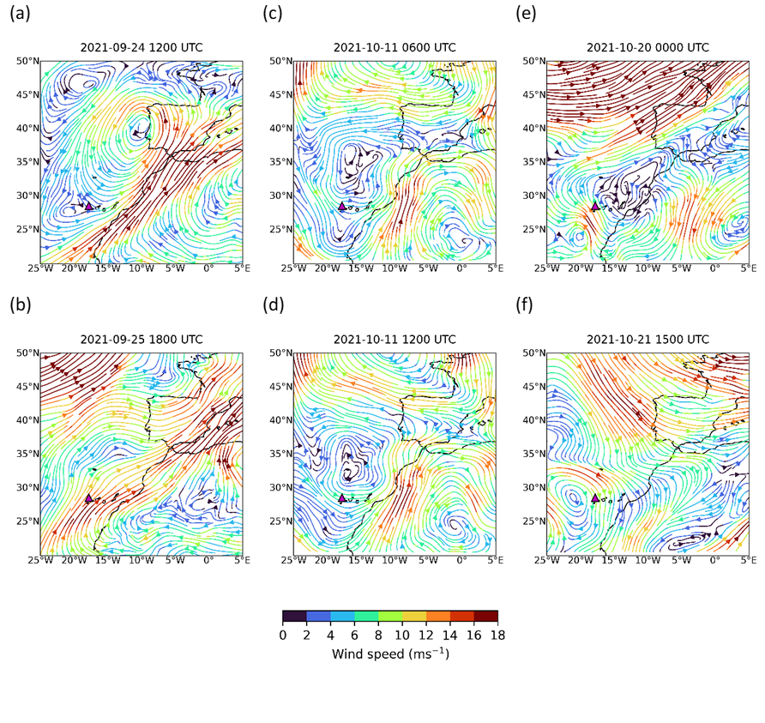
Figure S1. Wind speed and direction at 700 hPa from ECMWF ERA5 reanalysis: (a) 24 September at 12:00 UTC, (b) 25 September at 18:00 UTC, (c) 11 October at 06:00 UTC, (d) 11 October at 12:00 UTC, (e) 20 October at 00:00 UTC and (f) 21 October at 15:00 UTC.

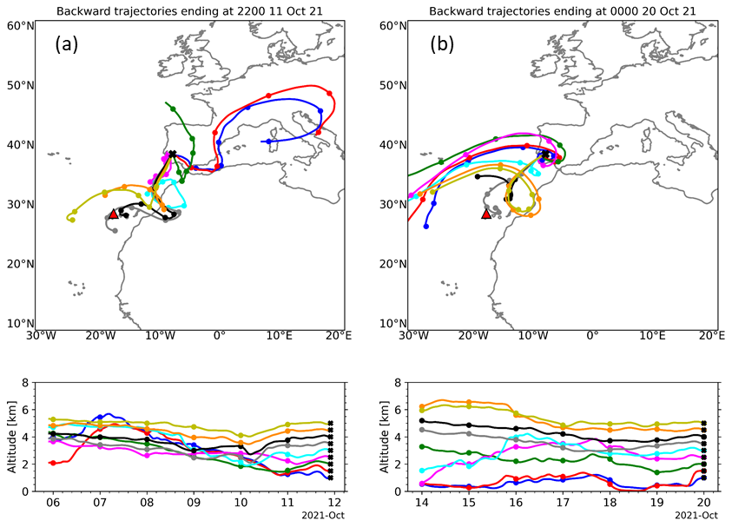
Figure S2. 144-h (6-day) Hysplit backward-trajectories arriving at Évora on 11 October 2021 at 22:00 UTC and on 20 October 2021 at 00:00 UTC, for altitudes from 1 to 5 km with steps of 0.5 km above ground level. The red triangle indicates the location of the Tajogaite volcano in the Canary Islands.
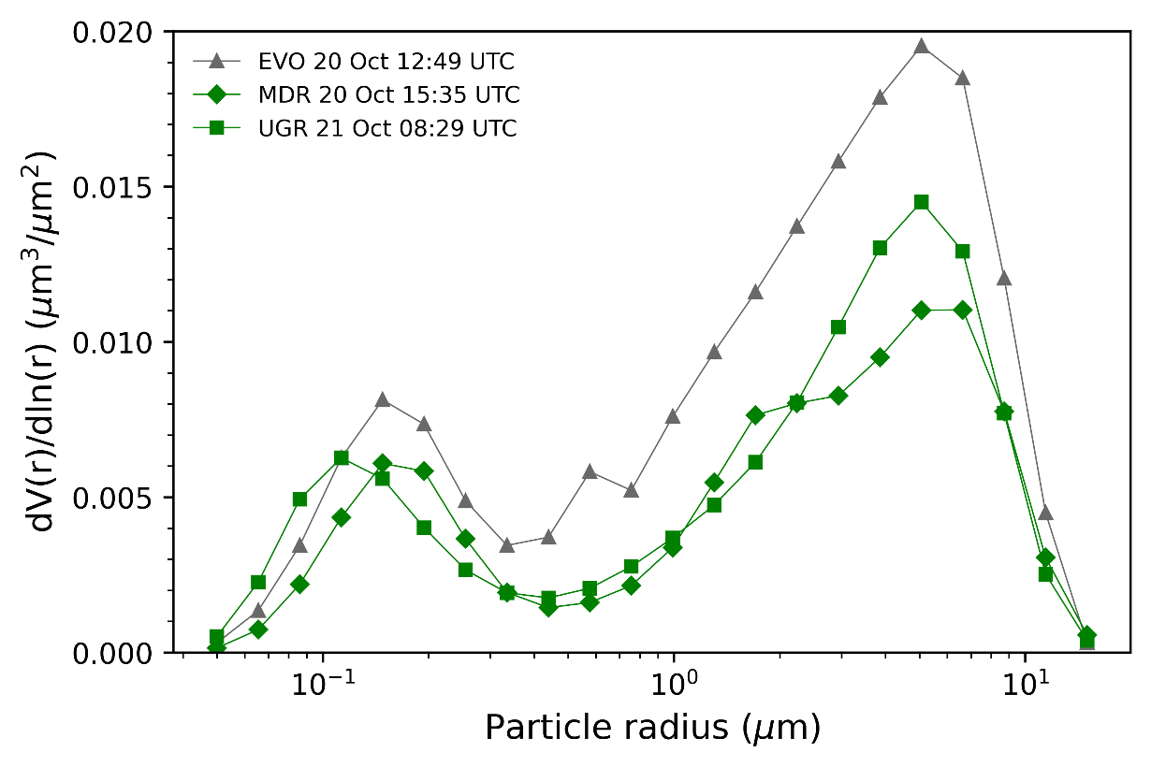
Figure S3. Aerosol volume size distributions in the atmospheric column from sun-photometer measurements for 22 logarithmically equidistant bins in the radius range from 0.05 to 15 µm in Event III.

Table S1. Mean values of AOD at 440 nm in the VA layer (${AOD}_{L}^{440}$) and in the atmospheric column (${AOD}_{C}^{440}$)) obtained from GRASP algorithm retrievals and the mean thickness values (Δz; km) of the VA layer. The values in brackets are the percentiles 10 and 90. The values marked with an * correspond to the unique available profile obtained on the corresponding day.
Site | VA properties | Event I |  |  | Event II |  |  | Event III
 |  | 25th Sep | 27th Sep | 28th Sep | 11th Oct | 12th Oct | 13th Oct | 20th Oct | 21st Oct
BCN | AOD_{L}⁴⁴⁰ | 0.135* | - | - | - | - | - | - | -
 | AOD_{C}⁴⁴⁰ | 0.262* | - | - | - | - | - | - | -
 | Δz | 2.824* | - | - | - | - | - | - | -
MDR | AOD_{L}⁴⁴⁰ | - | - | - | - | - | - | 0.014* | -
 | AOD_{C}⁴⁴⁰ | - | - | - | - | - | - | 0.080* | -
 | Δz (m) | - | - | - | - | - | - | 1.628* | -
UEX | AOD_{L}⁴⁴⁰ | - | - | - | - | 0.097  (0.067, 0.124) | - | - | -
 | AOD_{C}⁴⁴⁰ | - | - | - | - | 0.285  (0.272, 0.302) | - | - | -
 | Δz | - | - | - | - | 3.001  (2.803, 3.191) | - | - | -
EVO | AOD_{L}⁴⁴⁰ | - | - | - | - | 0.107  (0.087, 0.126) | - | 0.026* | -
 | AOD_{C}⁴⁴⁰ | - | - | - | - | 0.257  (0.251, 0.264) | - | 0.117* | -
 | Δz | - | - | - | - | 2.102  (1.907, 2.316) | - | 1.064* | -
GDN | AOD_{L}⁴⁴⁰ | 0.054  (0.014, 0.118) | - | 0.107  (0.094, 0.119) | 0.018* | 0.233  (0.154, 0.301) | - | - | -
 | AOD_{C}⁴⁴⁰ | 0.434  (0.364, 0.472) | - | 0.204  (0.201, 0.207) | 0.083* | 0.444  (0.414, 0.464) | - | - | -
 | Δz | 1.056  (0.579, 1.608) | - | 1.532  (1.426, 1.638) | 0.697* | 2.535  (2.185, 2.902) | - | - | -
UGR | AOD_{L}⁴⁴⁰ | 0.023  (0.008, 0.037) | 0.016  (0.012, 0.019) | 0.048  (0.036, 0.066) | - | 0.136  (0.119, 0.160) | 0.068  (0.041, 0.102) | - | 0.003  (0.003, 0.004)
 | AOD_{C}⁴⁴⁰ | 0.385  (0.308, 0.447) | 0.121  (0.112, 0.130) | 0.150  (0.131, 0.169) | - | 0.405  (0.352,0.467) | 0.224  (0.206, 0.247) | - | 0.107  (0.106, 0.109)
 | Δz | 0.878  (0.535, 1.221) | 0.659  (0.528, 0.816) | 0.945  (0.829, 1.114) | - | 2.735  (2.436, 2.986) | 1.085  (0.865, 1.366) | - | 0.663  (0.648, 0.677)
UGR^{CP} | AOD_{L}⁴⁴⁰ | 0.060  (0.025, 0.104) | 0.012  (0.009,0.015) | 0.027* | - | 0.139  (0.112, 0.170) | 0.113  (0.055, 0.178) | - | -
 | AOD_{C}⁴⁴⁰ | 0.237  (0.213, 0.280) | 0.069  (0.068, 0.070) | 0.056* | - | 0.323  (0.285, 0.381) | 0.168  (0.120, 0.226) | - | -
 | Δz (m) | 0.745  (0.491, 1.023) | 0.513  (0.442, 0.581) | 0.555* | - | 2.759  (2.575, 2.975) | 1.352  (0.927, 1.716) | - | -
ARN | AOD_{L}⁴⁴⁰ | - | 0.003  (0.002, 0.005) | 0.010  (0.004, 0.020) | 0.076  (0.036, 0.121) | 0.103  (0.099, 0.107) | 0.045  (0.041, 0.051) | - | -
 | AOD_{C}⁴⁴⁰ | - | 0.121  (0.101, 0.136) | 0.116  (0.088, 0.144) | 0.233  (0.166, 0.310) | 0.496  (0.495, 0.497) | 0.225  (0.212, 0.246) | - | -
 | Δz | - | 0.444  (0.361, 0.574) | 0.428  (0.272, 0.666) | 1.871  (1.434, 2.330) | 2.299  (2.281, 2.317) | 1.229  (0.886, 1.619) | - | -

