Figure S1: (a) Dependence of net photosynthesis (mg CO₂ gDW¹ hour¹) on temperature (°C) and PAR (µmols photons /m² s¹) obtained from GAM 1. (b) GAM 1 statistical outcome. The edf corresponds to the estimated degrees of freedom. P-value < 0.05 is considered as the minimum level of significance. The model has an R² value of 0.99 and explains 100% of the total deviance.

(a)
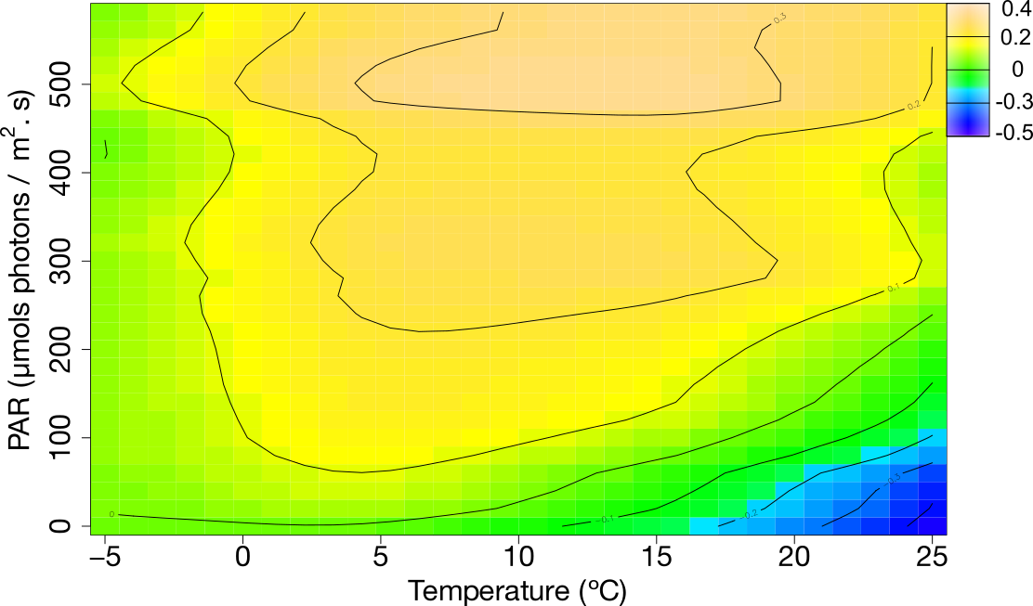

(b)

Smoothing terms | edf | Ref.df | F | p-value | p-value < 0.05
s(PAR) | 1 | 1 | 12.11 | 0.00316 | *
s(Temperature) | 7.569 | 7.921 | 121.44 | < 2e-16 | *
s(PAR, Temperature) | 22.314 | 24 | 407.44 | < 2e-16 | *

Figure S2: Macroclimate (black) and microclimate (red) from 2009 to 2014 at Livingston Island (maritime Antarctica). Daily means are given for (a) temperature, (b) PAR, and (c) relative humidity. The sum of daily precipitation is shown in (d).

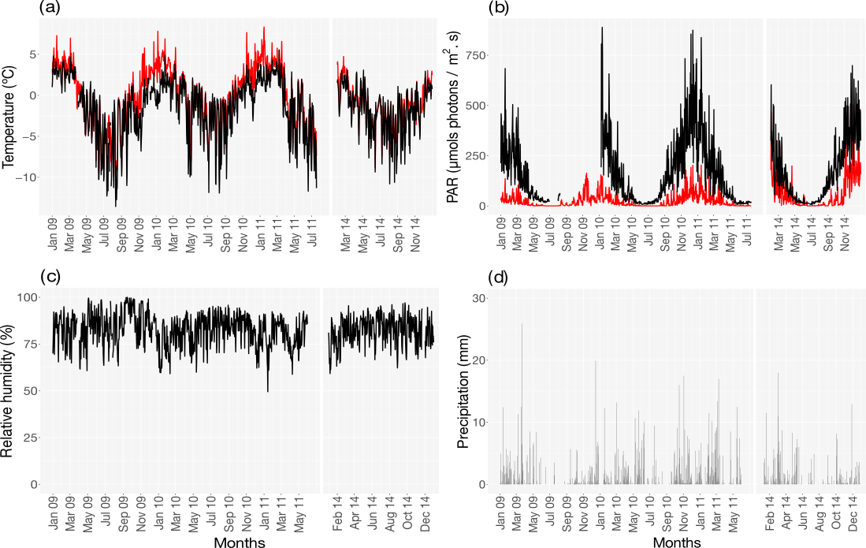

Figure S3: Daily mean of metabolic activity measured for Usnea aurantiaco-atra at Livingston Island (maritime Antarctica) from 2009 to 2014.
