Supplemental material for
Climatology of near-surface wind speed from observational, reanalysis and
high-resolution regional climate model data over the Tibetan Plateau

Lorenzo Minola^{1,2,3}, Gangfeng Zhang^{4,5,6}, Tinghai Ou¹, Julia Kukulies¹, Julia Curio¹,
Jose A. Guijarro⁷, Kaiqiang Deng⁸, Cesar Azorin-Molina³, Cheng Shen¹, Alessandro Pezzoli²,
and Deliang Chen¹

¹ Regional Climate Group, Department of Earth Sciences, University of Gothenburg, Gothenburg, Sweden.
² Interuniversity Department of Regional and Urban Studies and Planning (DIST), Politecnico and University of Turin, Turin, Italy
³ Centro de Investigaciones sobre Desertificación, Consejo Superior de Investigaciones Científicas (CIDE, CSIC-UV-Generalitat Valenciana), Climate, Atmosphere and Ocean Laboratory (Climatoc-Lab), Moncada, Valencia, Spain
⁴ State Key Laboratory of Earth Surface Processes and Resource Ecology, Beijing Normal University, Beijing, China
⁵ Academy of Disaster Reduction and Emergency Management, Ministry of Emergency Management and Ministry of Education, Beijing Normal University, Beijing, China
⁶ Department of System Science, Beijing Normal University, Beijing, China
⁷ State Meteorological Agency (AEMET), Delegation of the Balearic Islands, Palma de Mallorca, Spain
⁸ School of Atmospheric Sciences, Southern Marine Science and Engineering Guangdong Laboratory (Zhuhai), Sun Yat-sen University, Zhuhai, China

Fig. S1 Elevation map of the study area as represented by the 79-km horizontal resolution of ERAINT (a), by the 31-km horizontal resolution of ERA5 (b), and by the 9-km horizontal resolution of ERA5-Land (c).

Fig. S2 Scatter plot of the 1960-2020 mean of NSWS for the 104 stations over the TP plotted against the respective 1960-2020 standard deviation.

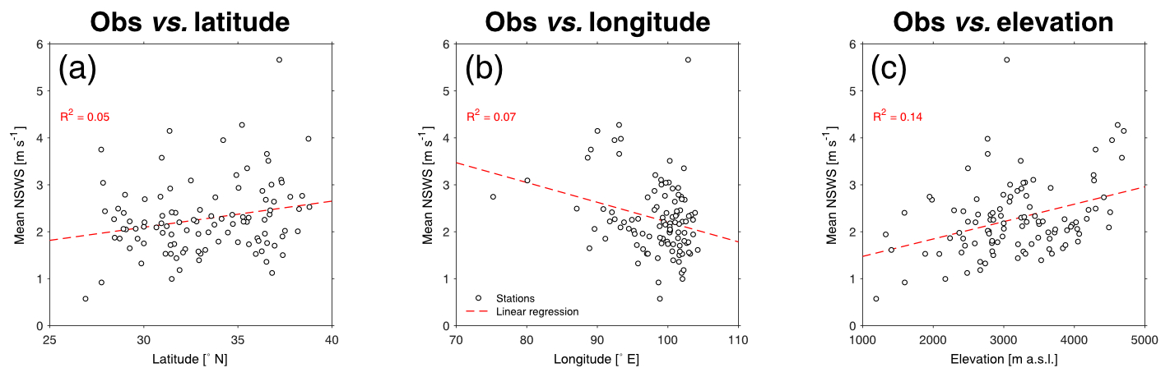

Fig. S3 Scatter plot of the 1960-2020 mean of NSWS for the 104 stations over the TP plotted against the station latitude (a), longitude (b), and elevation (c).

Fig. S4 Mean seasonal cycle of NSWS calculated using observations (black line), ERAINT (red line), ERA5 (blue line), and ERA5-Land (green line) for 1981-2018.

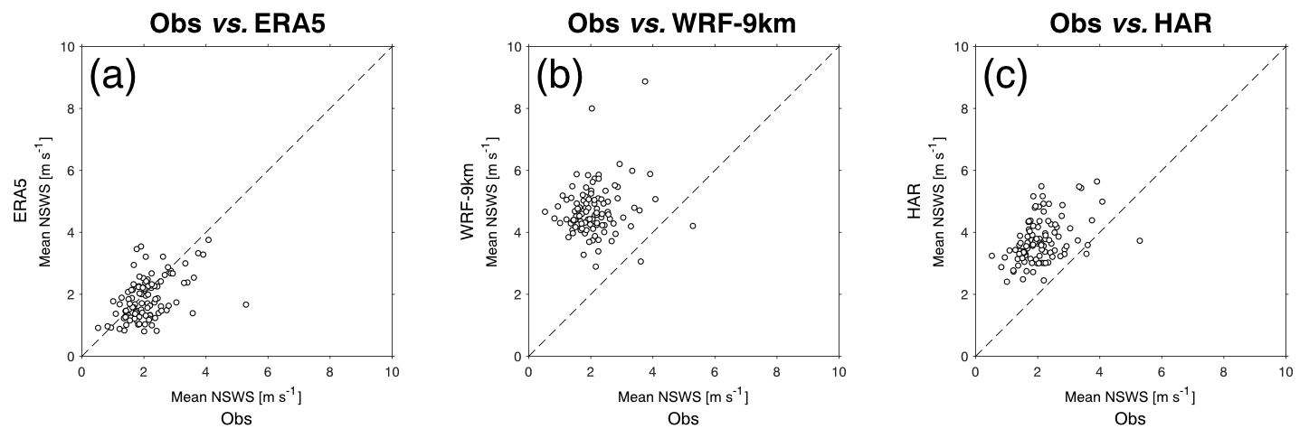

Fig. S5 Scatter plot of the 1997-2018 annual mean of the observed NSWS of the 46 stations over the TP plotted against the respective NSWS mean of the ERA5 closest grid-points (a), mean of the WRF-9km closest grid-points (b), and mean of the HAR closest grid-points (c).

Fig. S6 Mean seasonal cycle of NSWS calculated using observations (black line), ERA5 (blue line), WRF-9km (chocolate-colored line), and HAR (olive-colored line) for 1991-2018.

