Near-surface wind speed trends and variability over the Antarctic Peninsula, 1979-2022

Miguel Andres-Martin^{1,2}*, Cesar Azorin-Molina¹, Encarna Serrano², Sergi Gonzalez-Herrero^{3,4}, Jose A. Guijarro⁵, Shalenys Bedoya-Valestt¹, Eduardo Utrabo-Carazo¹, Sergio M. Vicente Serrano⁶

¹Centro de Investigaciones sobre Desertificación, Consejo Superior de Investigaciones
Científicas (CIDE, CSIC-UV-Generalitat Valenciana), Climate, Atmosphere and Ocean Laboratory (Climatoc-Lab), Moncada, Valencia, Spain
²Facultad CC. Físicas, Universidad Complutense de Madrid, Madrid, Spain
³ Antarctic Group, State Meteorological Agency (AEMET), Barcelona, Spain
⁴WSL Institute for Snow and Avalanche Research SLF, Davos, Switzerland
⁵Retired from the State Meteorological Agency (AEMET), Balearic Islands Office, Palma de Mallorca, Spain
⁶Instituto Pirenaico de Ecología, Consejo Superior de Investigaciones Científicas (IPE–CSIC), Zaragoza, Spain
Corresponding author: Miguel Andres-Martin, Centro de Investigaciones sobre Desertificación, Consejo Superior de Investigaciones Científicas (CIDE-CSIC-UV-GVA), Ctra. CV-315 km 10.7, 46113 Moncada, Valencia, Spain. E-mail: miguel.andres@csic.es

Supplementary material

Tables

Station | Source | Country | Lon. (Decº) | Lat. (Decº) | Lon. (Decº) ERA5 | Lon. (Decº) ERA5 | Period | Elevation a.s.l. (m)
Bellingshausen | SCAR MET-READER | Russia | 58.96 W | 62.20 S | 59.00 W | 62.25 S | 1968-2019 | 16
Esperanza | SCAR MET-READER | Argentina | 57.00 W | 63.40 S | 57.00 W | 63.50 S | 1957-2019 | 13
Faraday/Vernadsky | SCAR MET-READER | UK/Ukraine | 64.40 W | 65.40 S | 64.50 W | 65.50 S | 1950-2019 | 11
Juan Carlos I | AEMET | Spain | 60.40 W | 62.70 S | 60.50 W | 62.75 S | 1988-2019 | 12
Marambio | SCAR MET-READER | Argentina | 56.63 W | 64.23 S | 56.50 W | 64.25 S | 1971-2019 | 198
Marsh | SCAR MET-READER | Chile | 58.90 W | 62.20 S | 59.00 W | 62.25 S | 1970-2019 | 10
Rothera | SCAR MET-READER | UK | 68.10 W | 67.50 S | 68.00 W | 67.50 S | 1977-2019 | 32
San Martin | SCAR MET-READER | Argentina | 67.10 W | 68.10 S | 67.00 W | 68.00 S | 1977-2019 | 4
Table S1. Description of the meteorological stations used across the northern Antarctic Peninsula.

Figures
Fig. S1. Mean Sea level Pressure compute using ERA5 data for 1979-2022. ASL refers to Amundsen Bellingshausen Sea Low and WSL to Weddle Sea Low. The vectors show the direction and strength of the SWS anomalies.
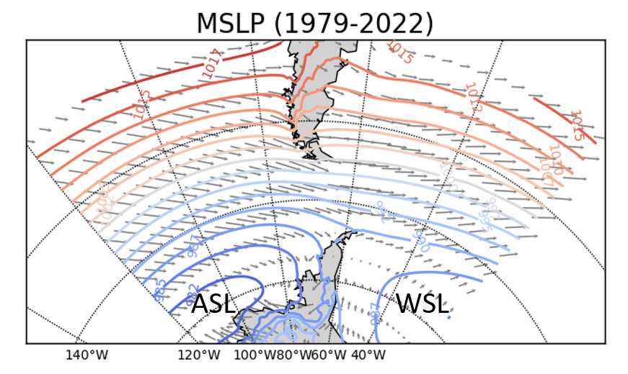

Fig. S2. Annual and seasonal SWS anomalies (in m s⁻¹) for JCI (black line) and ERA5 in the nearest grid point (blue line). The 10-yr Gaussian low-pass filters for both datasets are shown in dashed lines. A vertical solid and dash line shows the breakpoint year (p<0.05 and p<0.10 respectively, no line for p>0.10). The value of SWS anomaly trends (in m s⁻¹ dec⁻¹) before and after the breakpoint are shown, colored if statistically significant (p<0.05). Notice that the Y-axes range differs between the annual and seasonal plots.

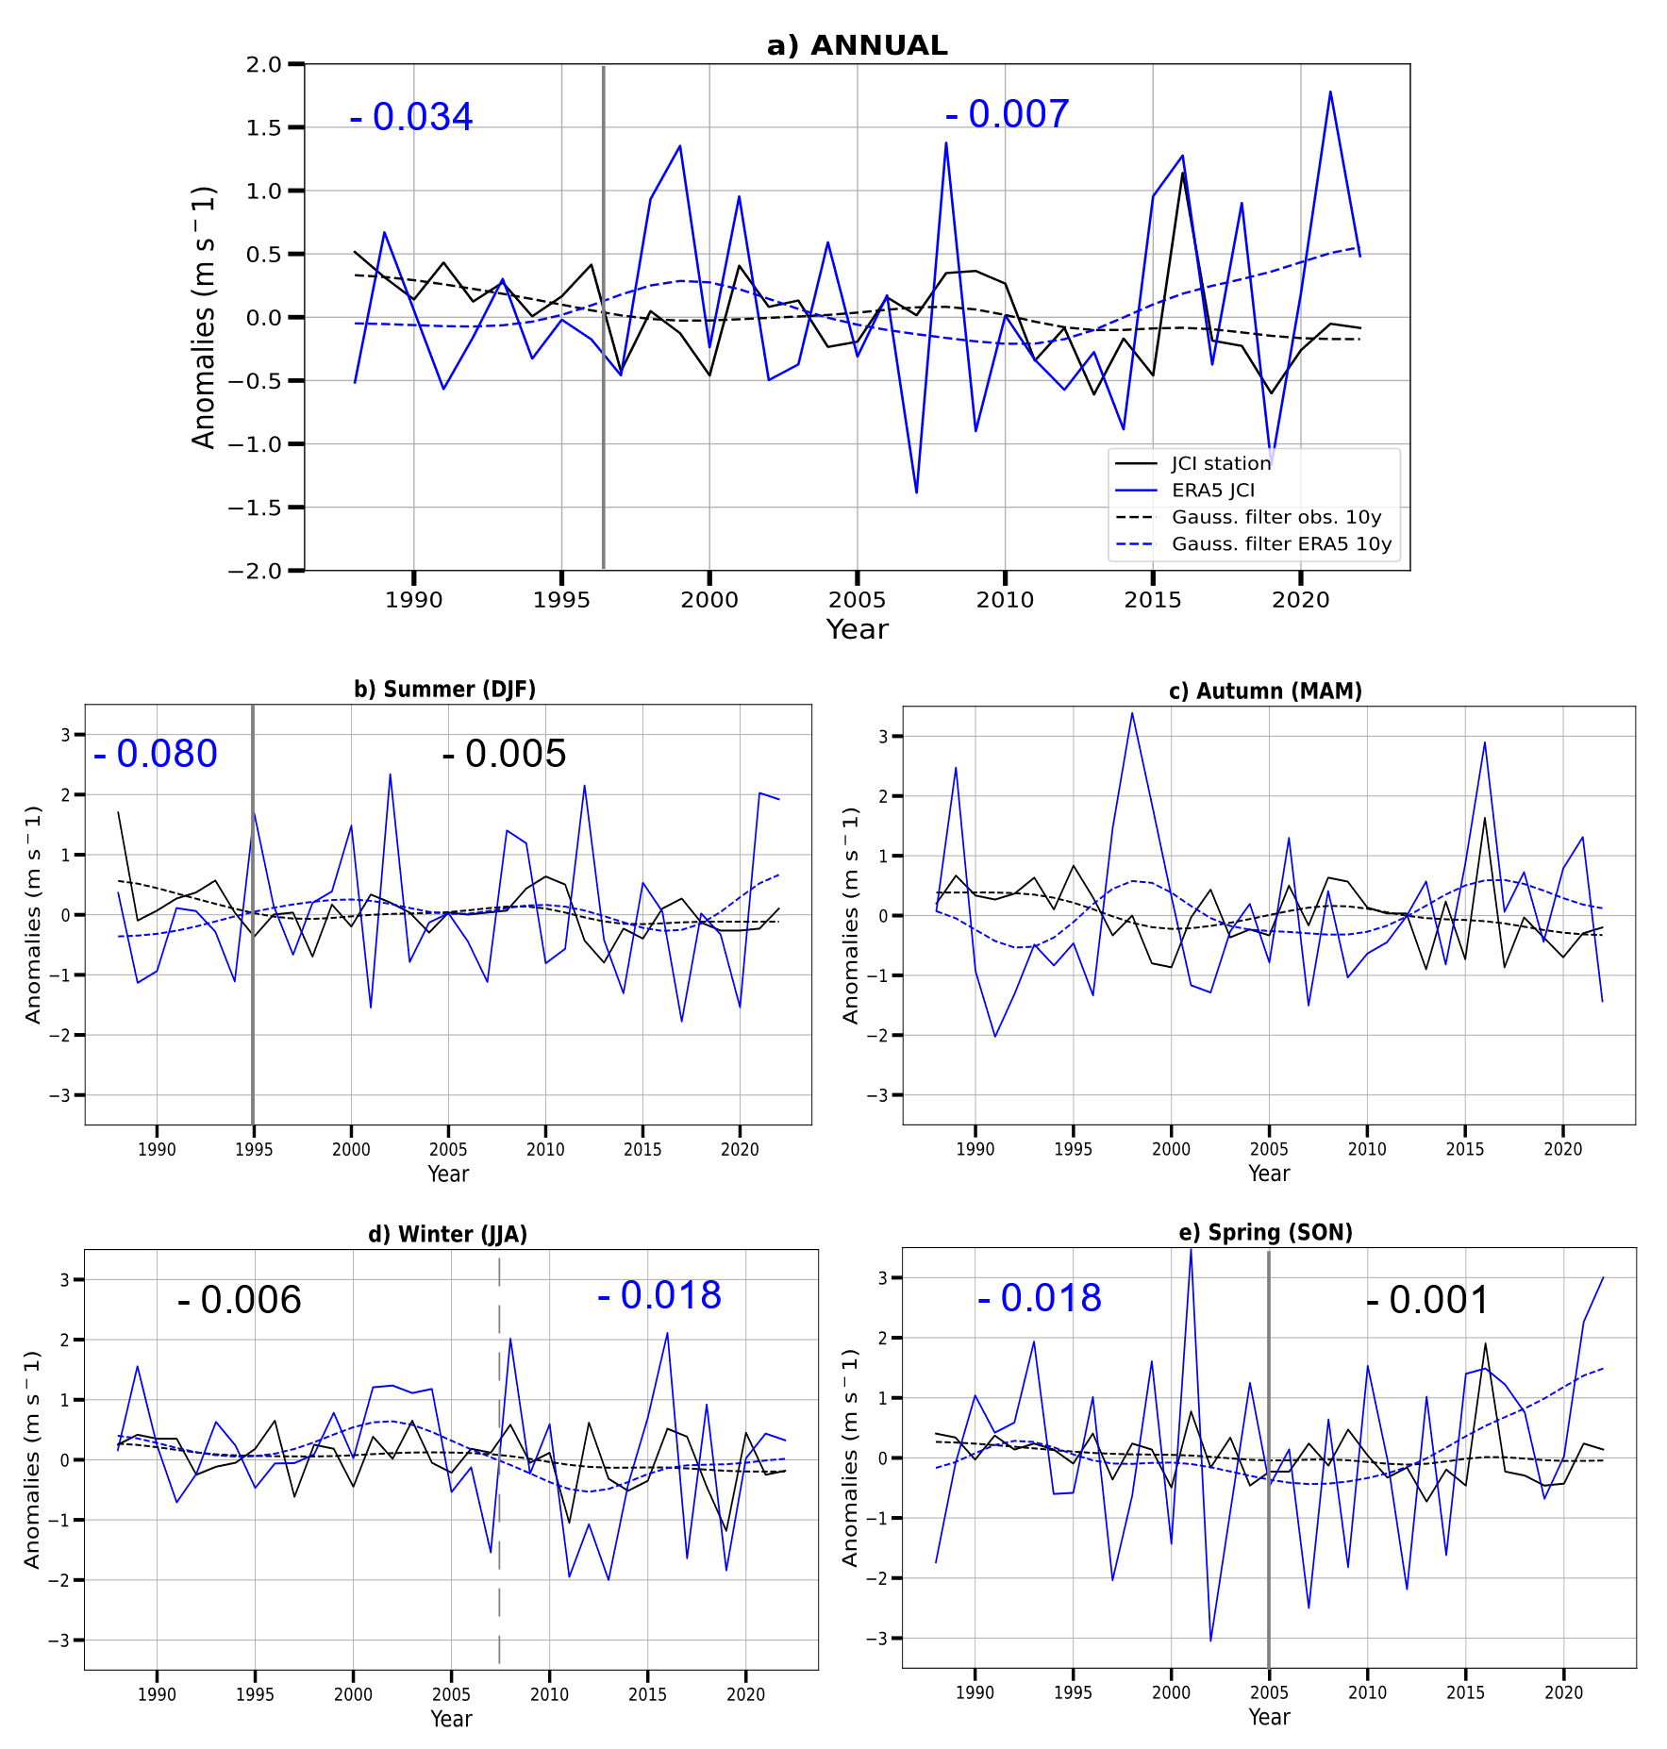

Fig. S3. Annual and seasonal regional mean (without JCI due to the different timespan) SWS (in m s⁻¹) for observations (black line) and ERA5 in the nearest grid point (blue line) for 1979-2022.
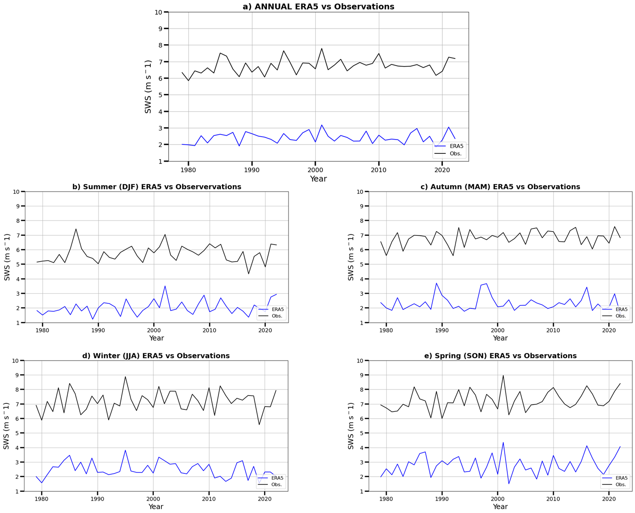

Fig. S4. Pearson correlation coefficient (r) between (a) SWS anomalies of the observational and (b) closest ERA5 grid points and the SAM index for 1979-2022. The asterisk in JCI indicates the different study period (1988-2022). Underlined values indicate statistical significance at p<0.10, and boxed values at p<0.05.

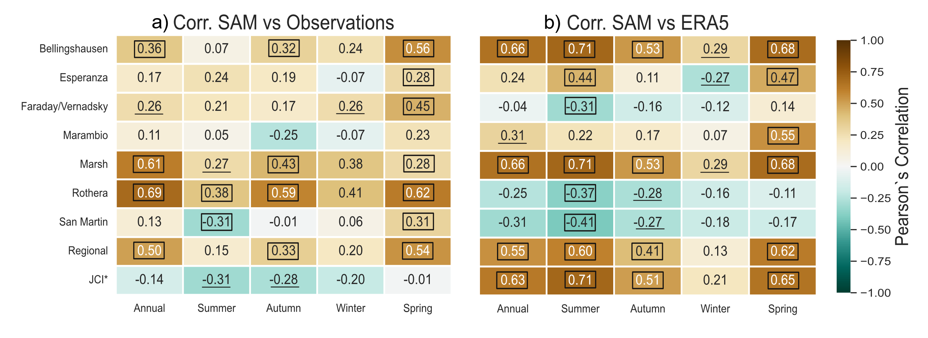
Fig. S5. Annual and seasonal regional mean (without JCI due to the different timespan) SWS anomalies (in m s⁻¹) observations (blue line) and the SAM index (red line). The 10-yr Gaussian low-pass filters for both datasets are shown in dashed lines. A vertical solid and dashed line indicate the breakpoint year for SWS regional mean anomalies (p<0.05 and p<0.10 respectively).
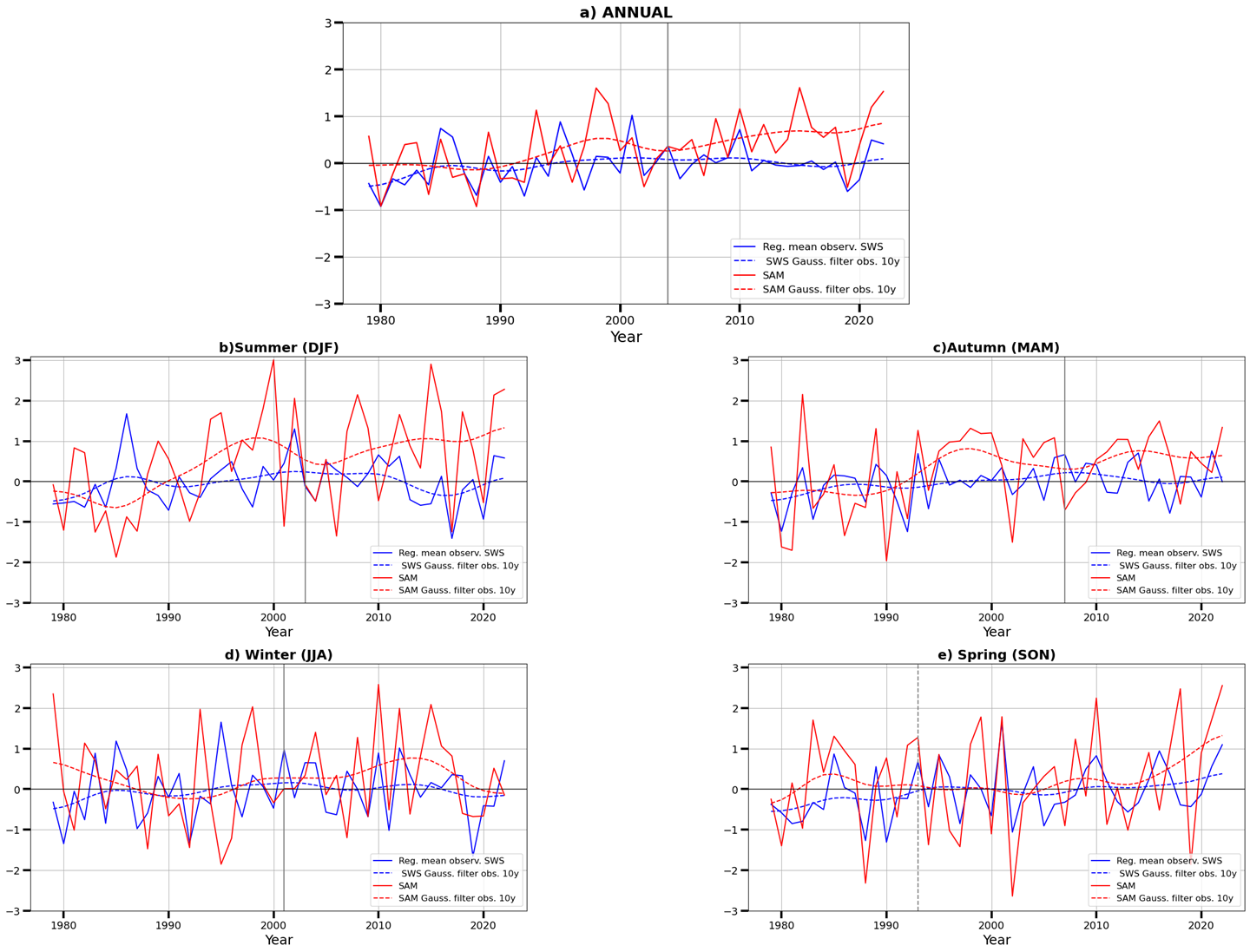

Fig. S6. Pearson correlation coefficient (r) between (a) SWS anomalies of the observational and (b) closest ERA5 grid points and the SOI index for 1979-2022. The asterisk in JCI indicates the different study period (1988-2022). Underlined values indicate statistical significance at p<0.10, and boxed values at p<0.05.
